**Automotive safety: FMCW radar for emergency braking**

I am working on a project focused on automotive radar technology. The goal is to develop a PCB capable of detecting both the speed and distance of the vehicle ahead. My idea is to create a programmable radar board that can generate the control signal for emergency braking. The emergency braking distance dynamically adjusts based on the differential speed between our vehicle and the one in front. The general diagram that summarizes:

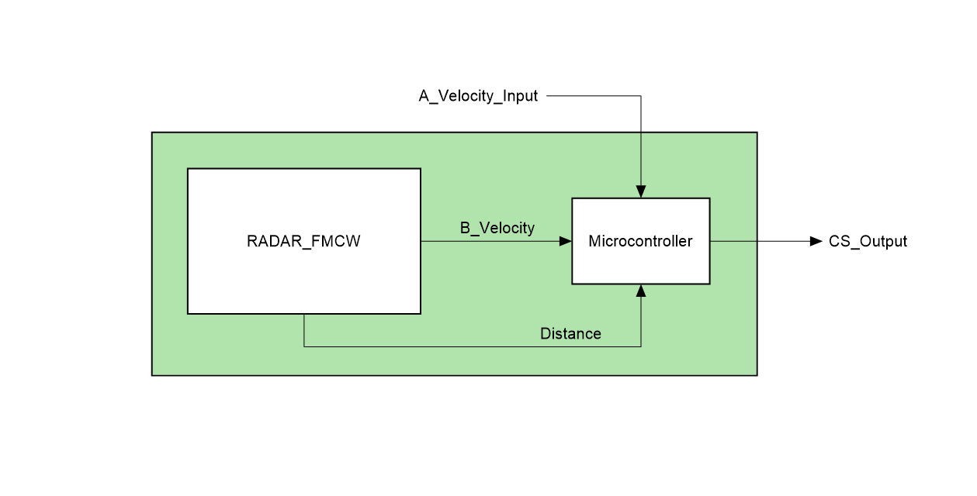

1. RADAR_FMCW: Antenna, VCO, low-noise amplifiers, filters, signal processing
2. A_Velocity_Input: It is the speed of the vehicle equipped with the radar
3. B_Velocity: It is the speed of the vehicle ahead, calculated by the radar
4. Distance: It is calculated based on the data detected by the radar
5. CS_Output: It is the control signal that triggers the emergency braking

**Basic automotive radar theory**

An automotive radar is a device that generates electromagnetic waves, which are typically emitted by an antenna and received by multiple antennas. The electromagnetic wave that bounces off an object and returns to the radar device is called an 'echo.' This echo is detected, amplified, and analyzed. To design automotive radar, one must have a deep understanding of high-frequency electromagnetic waves, specifically microwaves and mmWaves. While classical design at lower frequencies helps in understanding how automotive radar boards work, the PCB design rules are much more different and complex. Once the echo is received, an intermediate frequency mixing occurs to work with frequencies closer to the baseband of the transmitted signal. In the case of FMCW radar, a VCO is used to generate the necessary frequencies: the voltage-controlled oscillator converts a voltage signal into a frequency signal proportional to the voltage. The FMCW radar uses a sawtooth frequency modulation, with frequency variations adjustable based on the available bandwidth. On the following page, the input-output graph of a VCO in FMCW mode is shown:

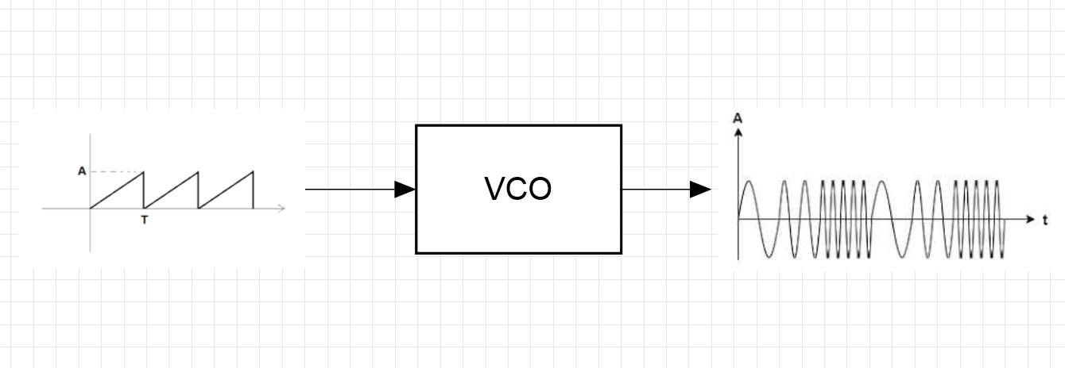

**Design parameters**

To design a radar, several parameters must be considered, such as the maximum range, bandwidth, transmitted power, carrier frequency, and radar cross section. The radar's electronic components must be sized according to the received power, which is typically very low, and they must account for losses and attenuation. In the case of my educational project, I will design an FMCW radar capable of detecting a fairly large radar cross section, making it simpler. My device will detect the vehicle ahead with a radar cross section equivalent to that of a car or motorcycle, so it will be of significant size. Below is an image that simply explains the concept:

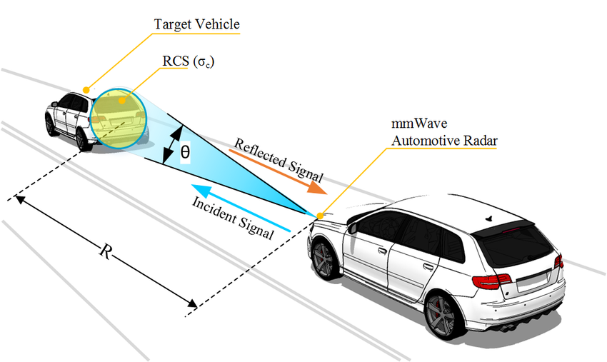

In my project, I will use only two antennas: one for transmission and one for reception, as I am only interested in detecting objects in the forward trajectory. I am not concerned with calculating the angular posit

**Antenna design**

The design of high-gain directional antennas is very complex, especially when using high frequencies. In my project, I will use patch array antennas with 50-ohm impedance matching. During antenna design, parameters such as frequency must be set, which allows for calculating the size of the rectangular patch. The patch array consists of N patches connected in series, which increases the antenna's directivity and, consequently, its gain. The general formulas for sizing a patch antenna are shown here:

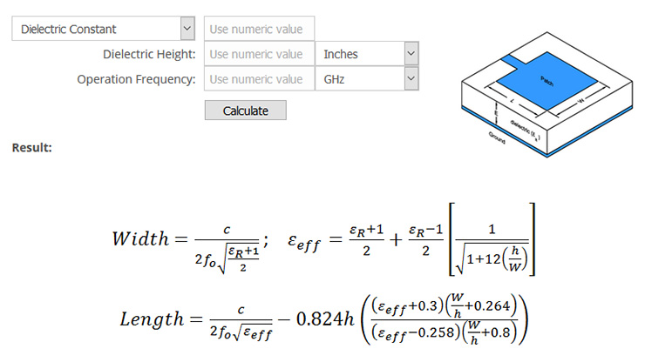

To significantly increase the antenna's directivity, we use N patches in series as shown in the figure below, designed according to specific design rules:

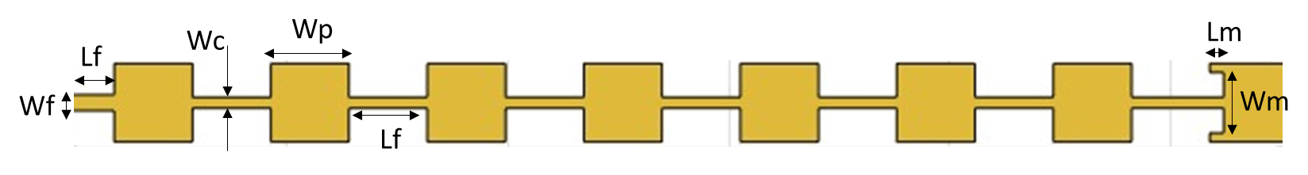

During the design process, it is important to consider the overall impedance of the array. The required impedance, typically 50 ohms, is necessary to prevent the signal from being reflected instead of radiated. Usually, the patch array has a significant impedance, depending on the series and parallel configuration of the elements; to address this issue, impedance matching is performed. There are many ways to match impedance. The method I will use in my project is called 'inset feed': an inset is placed within the patch to achieve a 50-ohm impedance match. Below is an illustrative image of the inset feed:

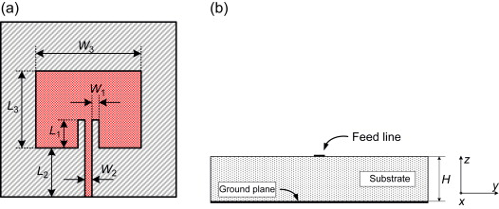

Depending on the frequency used, the substrate materials and thickness vary to achieve a more efficient patch with smaller dimensions. When using very high frequencies, greater than 10 GHz, we must consider very complex phenomena that occur within the layers of the pcb. For example, it is important to consider how the board is manufactured and how the layers are bonded, to avoid using materials with non-uniform surfaces that can cause disturbances at high frequencies (the layers typically have rough surfaces so they can be permanently bonded to other materials).

**Signal processing**

We know signal processing as a method for analyzing information carried by the baseband; in this case, the process is similar. Signal processing is carried out by a dedicated programmable processor, which performs the cross-correlation between the baseband transmission signal and the intermediate frequency reception signal. By correlating the two signals, we obtain information such as the differential frequency (or Doppler frequency) and the phase of the signals. With the obtained information, the processor calculates the object's speed (using electromagnetic Doppler effect formulas) and the distance (using the phase shift). In automotive radars, multiple receiving antennas are used, as explained earlier. This allows the processor to calculate the position and angular velocity of the target object. Unfortunately, in my project, I am currently unable to design a functional 'signal processing' system. It is proving to be too complex, and I would like to focus on other aspects.

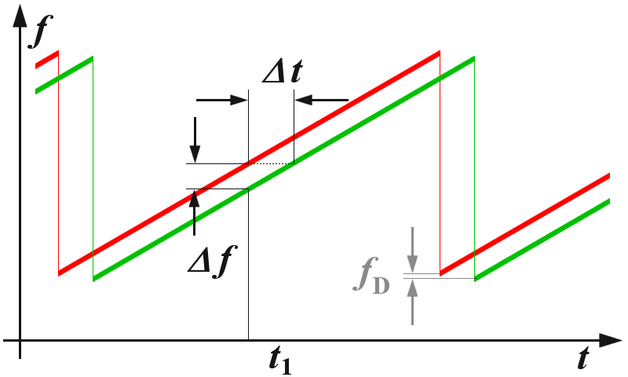

As shown in the graph above, we obtain both the transmission and reception signals in the baseband. If the reception signal has increased in frequency, the target object is moving; if the reception signal is delayed, I calculate the distance using radar propagation formulas

**Block diagram**

I have developed a possible diagram for my project that describes the FMCW radar. It is a simplified block diagram of the transmission and reception line. Here is the possible diagram:

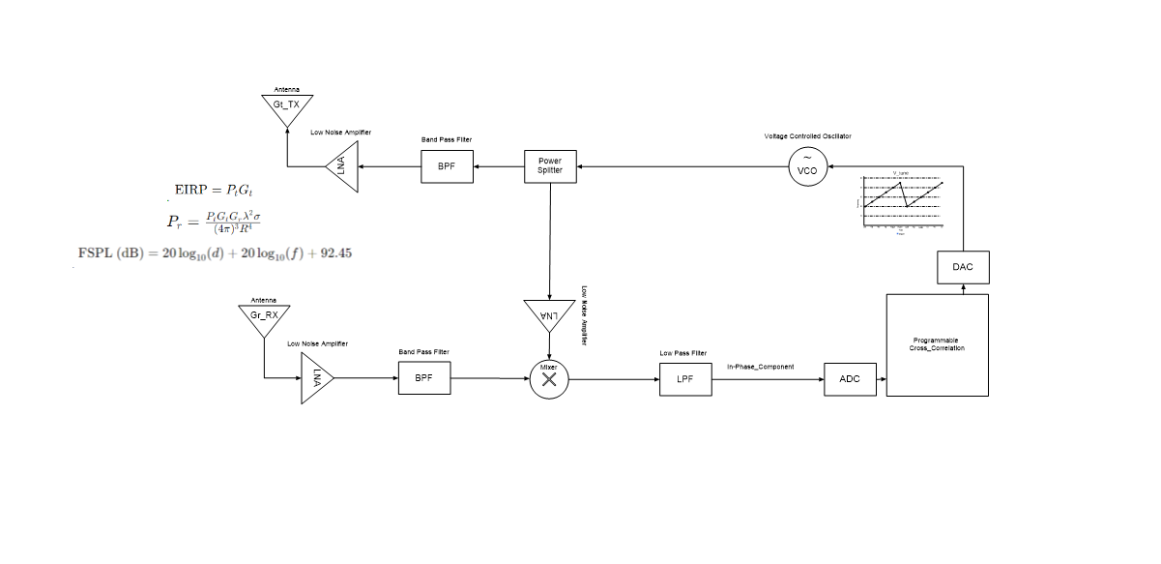

I haven't chosen the components I will use yet. Once selected, I will need to calculate the transmitted power, the losses along the transmission line, and the power received by the radar. Using radar formulas, we calculate the “free space loss”, EIRP (Effective Isotropic Radiated Power), and the received power based on the radar cross section. Below are the formulas:

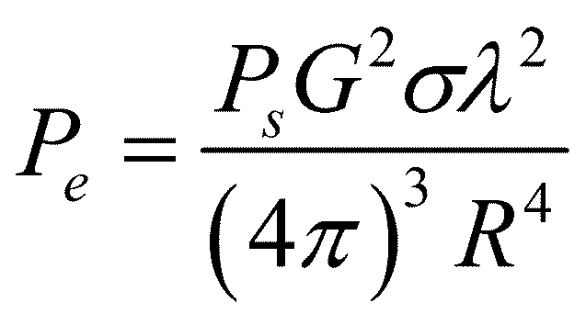

1. Ps = Transmission power
2. G = Antenna gain
3. Sigma = RCS (radar cross section)
4. Lambda = Wavelength
5. R = Distance

Once the requirements for my radar project are defined, I will solve the formulas to size the reception line.

**Electronic devices**

* Transmission line:

1. Voltage-controlled oscillator: HMC1163 Analog Devices

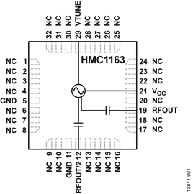

1. Power divider: MPD-0226SM Analog Devices

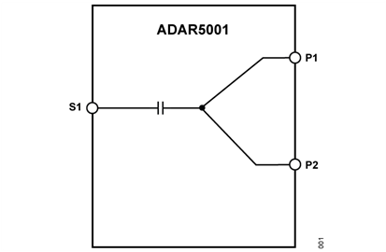

1. Low-noise amplifier: ADL8143 Analog Devices

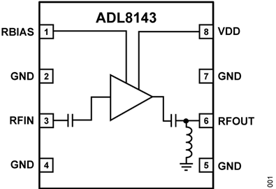

* Reception line:

1. Low-noise amplifier: ADL8143 Analog Devices
2. Band-pass filter: ADMV8416 Analog Devices

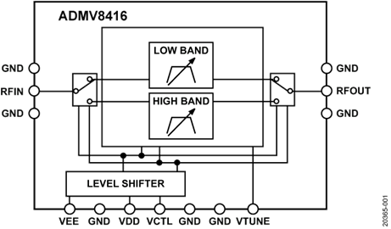

1. Mixer: ADMV1530 Analog Devices

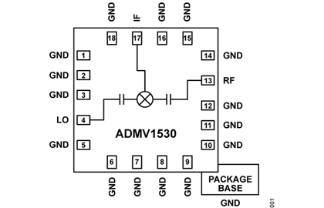

1. Low-pass filter: XLF-732+

